Spring Alignment Kit



# Change

The winds of Spring blow in, heralding change, sweeping us clean.

Spring Equinox is a time to release all that we don’t need anymore, in anticipation of new growth.

What do you want to release?

What can the wind sweep clean for you?

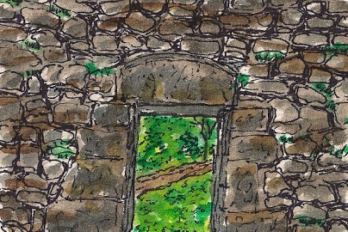

# Threshold

Spring Equinox is the threshold between Winter and Spring.

What is it to stand on a threshold?

What threshold are you standing on?

What do you want to leave behind?

What can you see from where you stand?

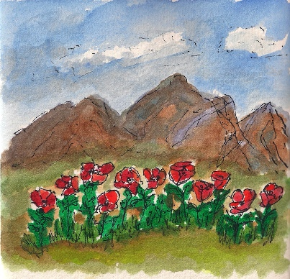

# New Territory

The energy of Spring thrusts us into new territories, almost whether we are ready or not. There’s a palpable urgency in the air.

What new territories are here for you to explore?

What new possibilities are calling to you?

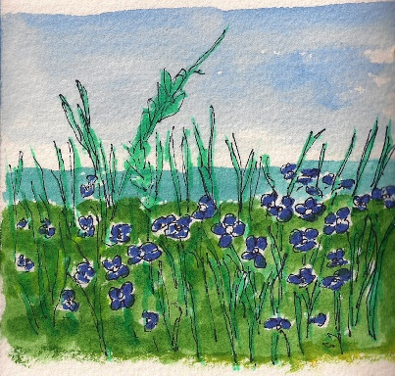

# Readiness

Spring energy refreshes us. We shake out the cobwebs of Winter and ready ourselves for new growth, opportunity, and adventures.

What will refresh and sustain you in your exploration of new possibilities?

How can the fresh energies of Spring support you in new growth?

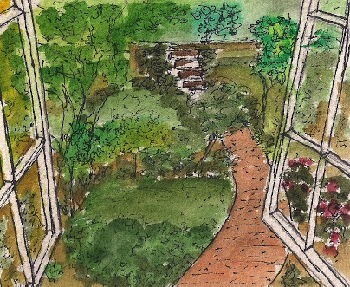

# Beginning

In Spring, Nature supports us in all manner of new beginnings.

What are you beginning?

What is it time for?

# If something important is emerging within you, and you would like to explore the Territory of New Possibilities….

# 

# and, Go with the Flow, while you’re at it:

# A Special 3-Call Coaching Package for Former Clients

Let’s discover more about your New Territories.

This is a No Materials, No Prep, Show Up Fully Present series of 3 forty-minute coaching calls, for USD 400.

Call #1: Explore the New Territory: What’s the New Territory? What’s calling you?

Call #2: Be the Explorer: Who is it important to be, as you move forward? What are the energies within you that are emerging, the ones that *need* expression?

Call #3: Begin to Act: What are the initial strategies and action plans that will begin to move you forward, boldly, into your new territories?

If you’re interested in this Coaching Package, please write to me at [Lynne Fairchild](mailto:lynnefairchild@earthlink.net?subject=Spring%20Coaching%20Special%20Package) and we can book times in our calendars.

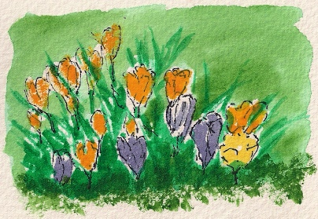

Thank you for giving yourself the time to reflect in this Spring Alignment Kit.

Wishing you many blessings in this Spring Equinox season,

Lynne

Lynne Fairchild, Professional Certified Coach

Lynne Fairchild, PCC, MBA

Wayfinding Coach

+1-815-568-8246

I offer Spiritual Time-Outs for Women Breadwinners who are über-committed, a little stressed-out, and are looking for balance and spiritual connection.

Select your favorite social media spots and let's connect:

Blog: <http://www.wayfindingcoach.com/blog>/

Facebook: <https://www.facebook.com/pages/Wayfinding-Coach/222888624404769>

Twitter: <http://twitter.com/#!/WayfindingCoach>

LinkedIn: <http://www.linkedin.com/in/lynnefairchild>

Website: [http://www.wayfindingcoach.com](http://www.wayfindingcoach.com/)/

