Summer Alignment Kit

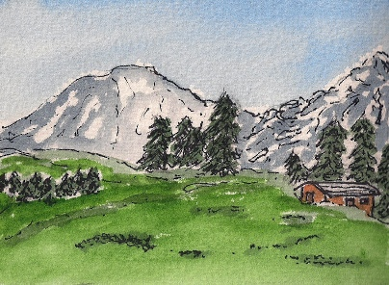

# Summer

Summer has a unique energy of expansion.

As much as we may associate Summer with ease and play, Summer also brings with it power and growth.

There is a feeling of flow to Summer’s natural unfolding.

As these energies are expressed in Nature, so they are moving within us, informing us and guiding us in the emergence of the next phase of our life’s journey.

# Expansion

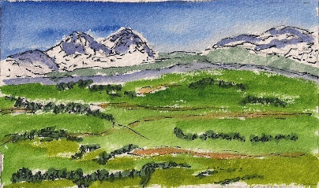

In Summer, everything in Nature is surging with growth and expansion.

How are you being called to grow?

What new territories is life moving you into?

# Ease

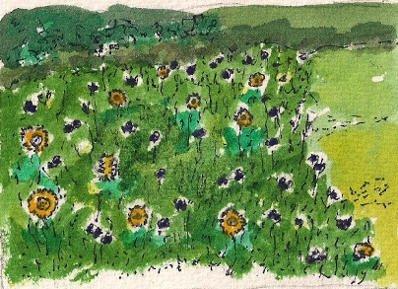

There’s a natural ease associated with Summertime.

How can you allow yourself to relax into your life and your expansion and growth with a feeling of ease?

What would it take for you to give into more ease, and allow it into your life?

What would be different if you did allow ease to be more present in your life?

# Power

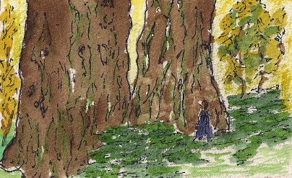

Behind all the growth that we see in Nature is the power of the season. There is a no-holding-back quality to Summer. This power is natural and authentic, like the life force that makes the trees grow.

Your authentic power is always available to you.

How do you tap into the energy, wisdom, and guidance of your truest and deepest self?

# Flow

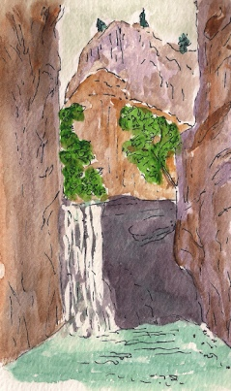

Think of the momentum that is present in rivers and waterfalls.

Feel the power and inevitability of that natural flow.

Just as there is a natural power and energy in rivers and waterfalls, there is the flow of this life force in you.

Feel the flow of power and energy within you.

Where is life carrying you?

What if you trust the flow?

# Special Summer Coaching Offer for Prior Clients

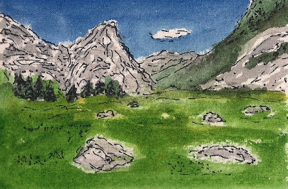

## Summer Stock-take

This is a No Materials, No Prep, Show Up Fully Present series of 3 forty-minute coaching calls, for USD 400.

Call #1: Expansion: What new territories are emerging within me to be explored?

Call #2: Authentic Power: What helps me access my own natural power?

Call #3: Flow: How do I release into the flow of my life with ease? How do I co-operate with life as it is unfolding within me?

If you’re interested in this Coaching Package, please write to me at [Lynne Fairchild](mailto:lynnefairchild@earthlink.net?subject=Spring%20Coaching%20Special%20Package) and we can book times in our calendars.

## Coming Soon: Coaching in the Realm of Being

A special coaching offer that is specially designed to help you discern your own unique, personal Compass for Being.

North: Intentions for Being

East: Manifesto

South: Legacy

West: Core Essence

Thank you for giving yourself the time to reflect in this Spring Alignment Kit.

Wishing you many blessings in this Summer Solstice season,

Lynne

Lynne Fairchild, Professional Certified Coach

Lynne Fairchild, PCC, MBA

Wayfinding Coach

+1-815-568-8246

I offer Spiritual Time-Outs for Women Breadwinners who are über-committed, a little stressed-out, and are looking for balance and spiritual connection.

Select your favorite social media spots and let's connect:

Blog: <http://www.wayfindingcoach.com/blog>/

Facebook: <https://www.facebook.com/pages/Wayfinding-Coach/222888624404769>

Twitter: <http://twitter.com/#!/WayfindingCoach>

LinkedIn: <http://www.linkedin.com/in/lynnefairchild>

Website: [http://www.wayfindingcoach.com](http://www.wayfindingcoach.com/)/

