Autumn Alignment Kit

# Harvest

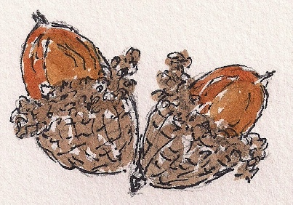

We are on the threshold of Summer and Autumn. Summer is now behind us, and Autumn has begun, abundant with the harvest.

What has Summer been for you this year?

Who have you allowed yourself to be, in Summer?

What is ready for harvest?

# Threshold

# 

What gifts of Summer would you like to take into Autumn?

What do you want to leave behind?

# Opening

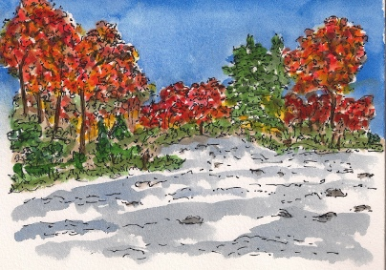

What’s opening up for you?

Where’s the momentum in your life?

What is pulling you forward?

# New Horizons

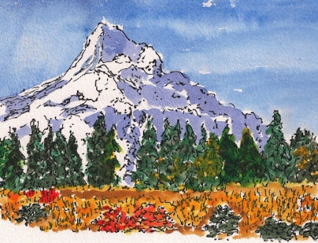

What do you see on the horizon of your life?

What new territories are there to explore?

What really matters, for Autumn?

# Intentions for Being

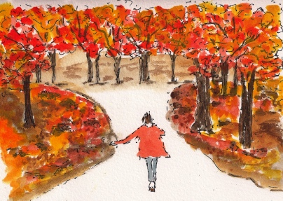

What energy do you want to bring into Autumn?

What are your Intentions for Being?

What are your key commitments to yourself for the Autumn season?

# Special Coaching Offer: Compass of Being, Living It

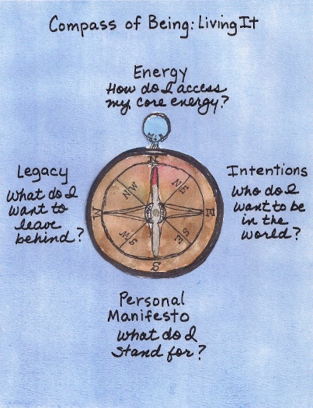

“Traveler, there is no path. Paths are made by walking.” – Antonio Machado

*What is the path you want to make?* Your Compass of Being guides your way.

I’m offering a special coaching opportunity for you to create your own, personal Compass of Being. We’ll create sacred space together and you will illuminate and clarify your unique answers to these compass points:

* **Energy**: How do I access my Core Energy?
* **Intentions:** Who do I want to be in the world?
* **Personal Manifesto**: What do I stand for?
* **Legacy**: What do I want to leave behind?

Then, you will live it.

We will design the coaching structure and alliance specifically to meet your needs, with a commitment of four months, minimum. Something this powerful is to be discerned over time, not overnight.

My customary coaching rates apply, to be invoiced in alignment with the unique structure that fits your needs.

If this is calling to you, please write to me at [Lynne Fairchild](mailto:lynnefairchild@earthlink.net?subject=Compass%20of%20Being%20Coaching), and we will schedule a time to connect by phone to design our coaching alliance for this special piece of work.

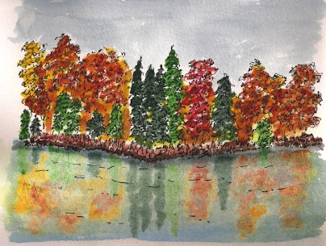

Thank you for giving yourself the time to reflect in this Autumn Alignment Kit.

Wishing you many blessings in this Autumn Equinox season.

Lynne

Lynne Fairchild, Professional Certified Coach

Lynne Fairchild, PCC, MBA

Wayfinding Coach

+1-815-568-8246

I offer Spiritual Time-Outs for Women Breadwinners who are über-committed, a little stressed-out, and are looking for balance and spiritual connection.

Select your favorite social media spots and let's connect:

Blog: <http://www.wayfindingcoach.com/blog>/

Facebook: <https://www.facebook.com/pages/Wayfinding-Coach/222888624404769>

Twitter: <http://twitter.com/#!/WayfindingCoach>

LinkedIn: <http://www.linkedin.com/in/lynnefairchild>

Website: [http://www.wayfindingcoach.com](http://www.wayfindingcoach.com/)/

