Spring Alignment Kit 2015

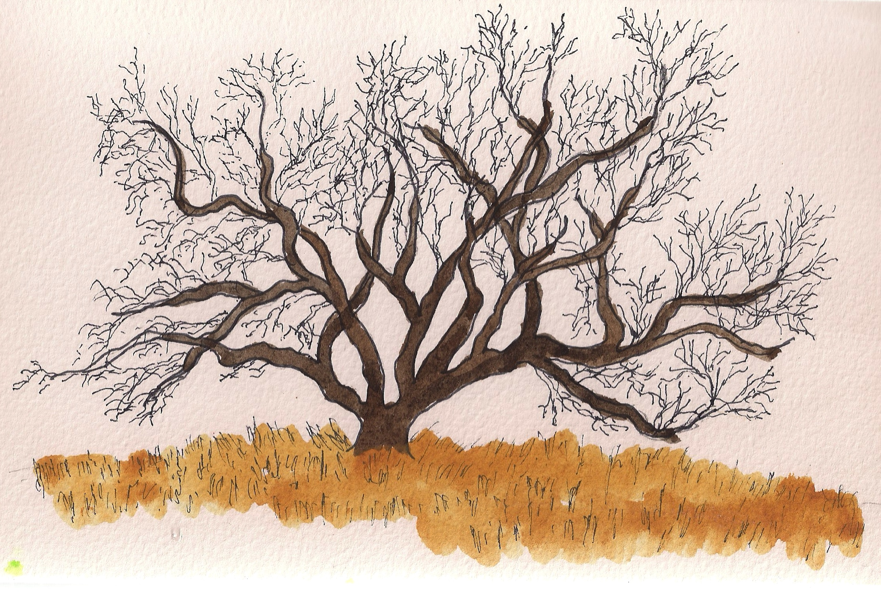Awakening

Many of you have been receiving my Alignment Kits for many years. This one is a bit different.

This year, I was inspired to create a short (10 minutes) audio movement meditation, and just three simple questions for you to write about after you do the meditation.

It’s a meditation where you get up and move your body, and in your imagination, you become a favorite tree, as it is awakening in Spring, after a long Winter of rest.

The intuition from our true selves often reveals itself through our bodies. You’ve probably had the experience of being inspired as you were moving; there’s something about the energy flowing that activates inspiration. You are fully present in your body, and insights begin to flow. Or, as you are making decisions, one choice just “feels right.”

Our bodies are wonderful channels for wisdom to flow. I hope you enjoy the meditation and the questions. Play the meditation and explore the questions on the next page.

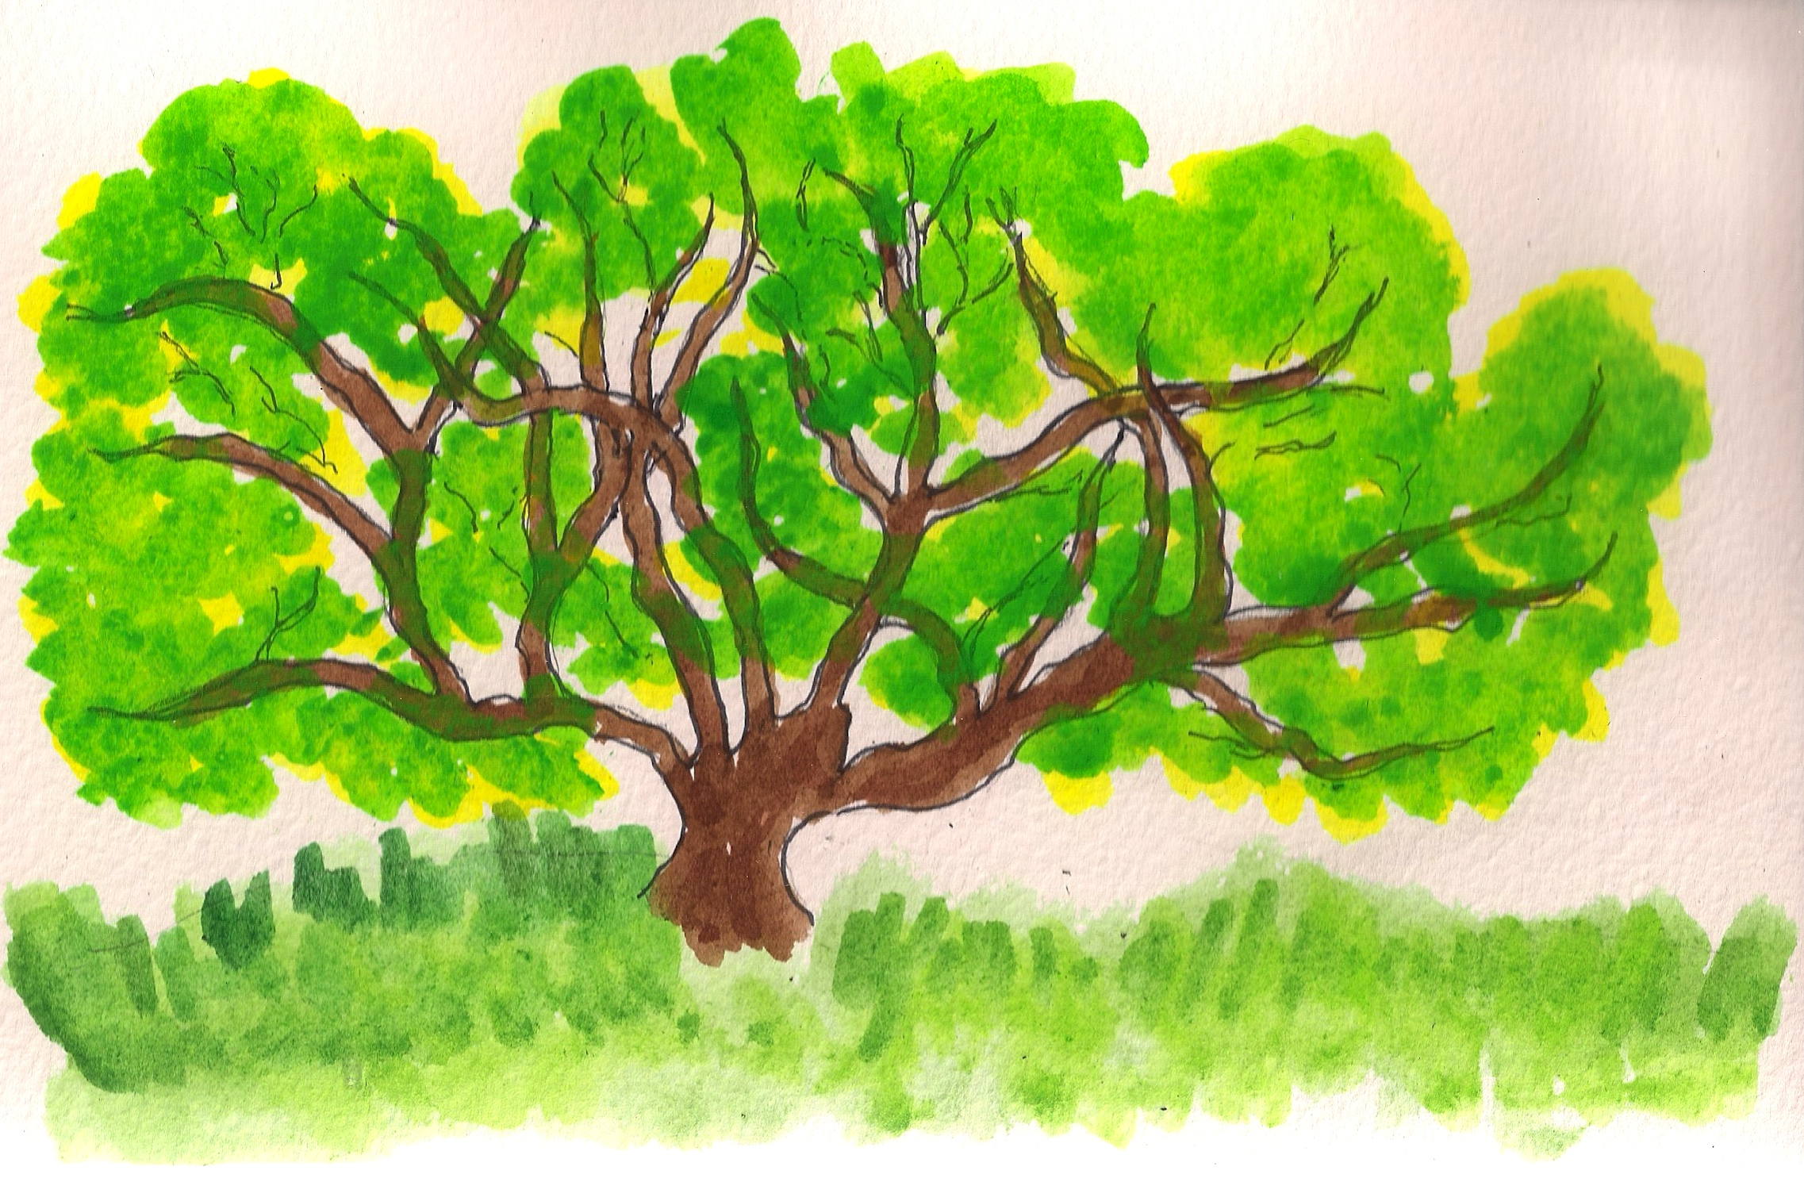As You Awaken

What, in you, is awakening?

How can you move and grow with it?

What is this awakening inviting you to do in the world?

