Barbara Long, MT ~ MFR of Central California

DAILY PROGRESS NOTE

PATIENT NAME: __________________________________________ DATE: ____/____/____

PATIENT’S DESCRIPTION OF CURRENT CONDITION:
____________________________________________________________________________________________________________________________________________________________________________
____________________________________________________________________________________________________________________________________________________________________________

PLEASE INDICATE SYMPTOM AREAS ON THESE DIAGRAMS AND RATE THE INTENSITY OF EACH AREA USING THE FOLLOWING SCALE:

NONE MILD MODERATE SEVERE

PAIN LEVEL 0 1 2 3 4 5 6 7 8 9 10

R
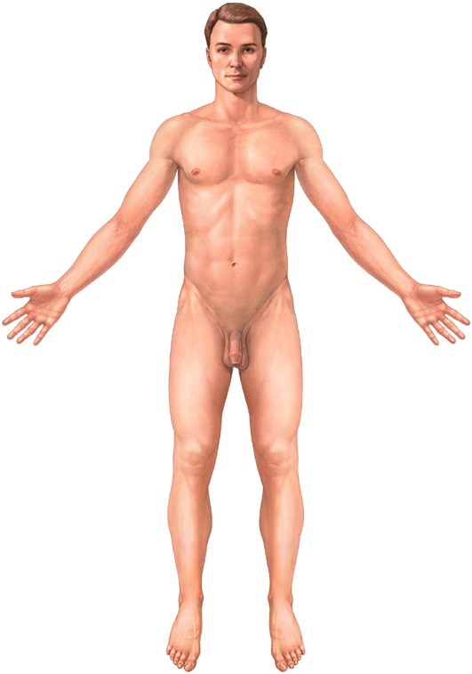
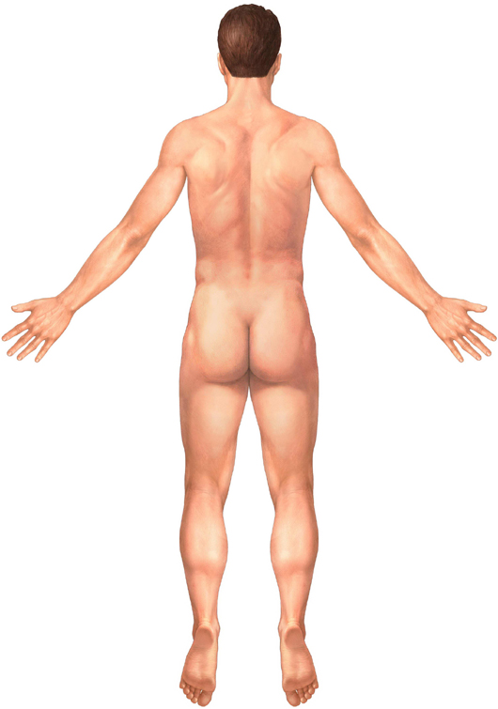

PATIENT SIGNATURE: _______________________________________________________________

